Alternate Text for Facebook

Introduction
Image descriptions can be difficult for those who are unfamiliar with image descriptions. Image descriptions are described to convey information to the user that would often be obtained through the eyes. The question becomes, “how much information do I need to provide?”. If you provide too much information, it may overwhelm users with reading disabilities. Providing too little of information may hinder users with visual disabilities from obtaining the necessary information. More information about sparse and lush image descriptions may be found in the Image Descriptions and How to Write Them toolkit file.
[DIRECT LINK]: http://tinyurl.com/ImageDescriptionToolkit

Styles of Alternate Text for Facebook:
With Facebook, there are three styles for providing alternate text. You may either provide alternate text that describes the picture in the initial post, you may choose to do so in the comments, or you may enable hidden alternate text (if using a computer or IOS device). If you provide the alternate text in the initial post, we recommend placing the text in brackets and/or writing the words “Alternate text” or “Image Description” prior to your description. This will allow users who use a screen-reader the opportunity to prepare for a description of an image.

A great example of using in-post alternate text may be found on the Joshua Tree National Park’s Facebook page. Direct link to referenced post: https://www.facebook.com/JoshuaTreeNPS/photos/a.10150574799050181.673608.138794585180/10158748491445181/?type=3&theater .

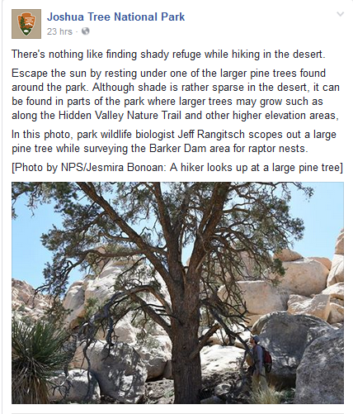

Some users choose to place alternate text in the comments instead. This may be useful if a photo requires a large/lush description for a screen-reader user to understand, and is so detailed that it may be aversive to someone with a reading disability. If you switch between the two styles of alternate text on Facebook, you may wish to add “alternate text in comments” to your post. You will also want to make sure that your comments are shown in chronological order. To change your comments to chronological order, go to the bottom of your post and then click the word chronological or top comments. This will be next to the names of people who have liked your post. Make sure the checkmark is next to the word “chronological” instead of “top comments.” Below is a screenshot of this toggle setting.

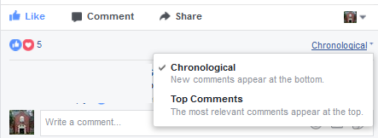

For an example of alternate text in the comments section, please refer to this post from the UGA Disability Resource Center, which may be found at this link (www.tinyurl.com/AltTextComments), or in the screenshot below, which has alternate text.
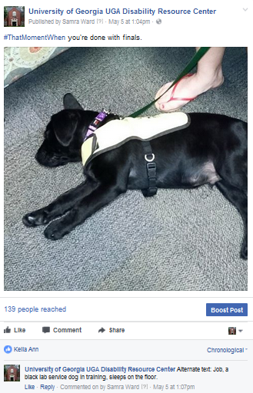

For an example of hidden alternate text, please refer to the screenshots below:
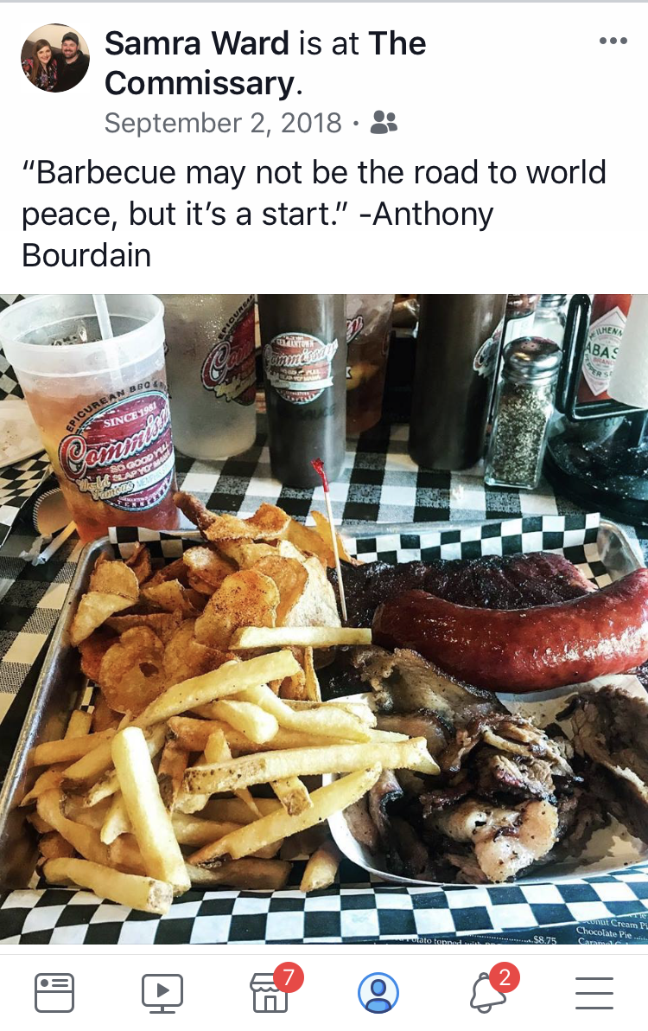
Screenshot one shows a Facebook post written by Samra Ward on September 2, 2018 with the caption: “Barbecue may not be the road to world peace, but it’s a start. - Anthony Bourdain.”

Beneath the text is a photo of barbecue that has hidden alternate text.

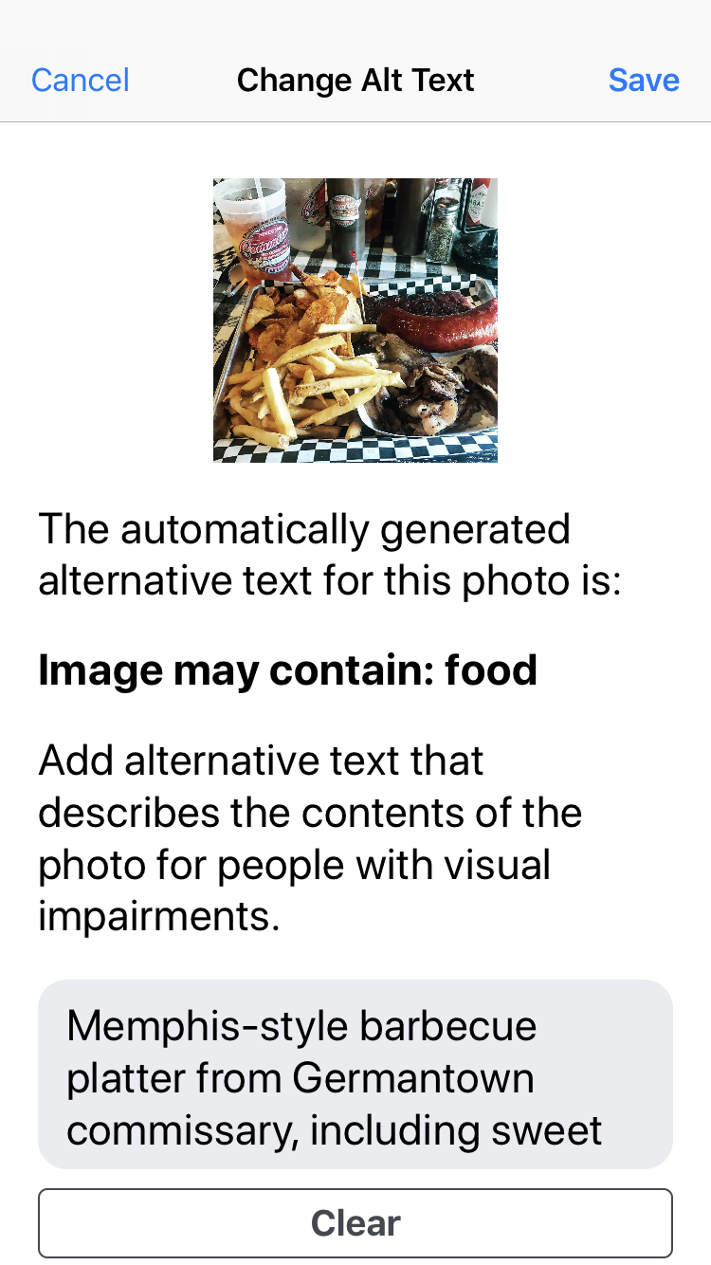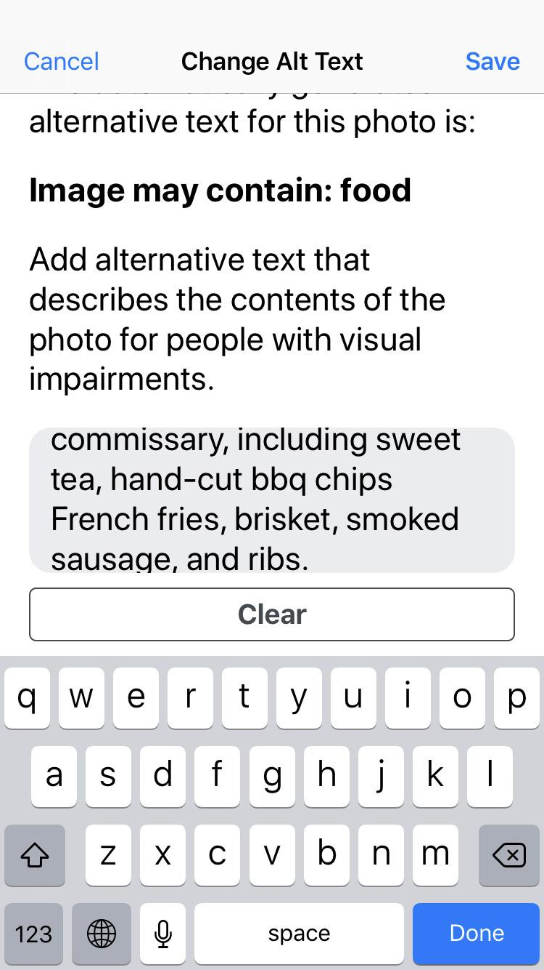
Screenshots two and three show what the automatically-generated alternative text that Facebook created for this post, “Image may contain: food.” It is important to the poster that users know what specific type of food is shown, so the original poster overrides the automated alternative text to create her own. Samra’s replacement alternate text reads as follows: “Memphis-style barbecue platter from Germantown Commissary, including sweet tea, hand-cut barbecue chips, French fries, brisket, smoked sausage, and ribs.

Step by step instructions for creating hidden alternative text may be found on Facebook’s FAQ section. Link: https://www.facebook.com/help/214124458607871?helpref=faq_content

