Creating Useful Alternative Text for Twitter
Samra Ward, M.A.

Introduction
In the Image Descriptions and How to Write Them toolkit file, we gave information about the difference between sparse and lush alternate text. For your reference, a direct link is available here: http://tinyurl.com/ImageDescriptionToolkit .

Twitter alternate text is limited to 420 characters, including spaces, so keep this in mind when creating alternate text. Alternate text is not visible to users who do not use screen-readers, so you may want to use more detail in describing the image, if you believe it to be fundamental to the user’s overall understanding.

Retweeting Others’ Posts
Because alternative text is not easily visible on twitter, you will want to check before retweeting someone else’s post that has an image. To check on a Windows computer, you will right click the image and click “view image info.” A dialog box will pop up, and there will be a section entitled “associated text.” If a custom alternative text has been written, it will appear in that section.

You will want to decide whether or not to retweet someone’s post who does not have alternate text. From a personal perspective, I (Samra) do not retweet anyone’s posts without alternate text, because I believe it excludes too many people. I either do not share the inaccessible tweet, or I will “quote” the tweet and pull relevant information from the graphic. To quote a tweet, access the double arrow button (retweet button). On a browser, you can “add comment” to quote a tweet. Within phone apps, you may select “quote tweet” to add comments.

Examples of Alternative Text On Twitter
The following is an example of a quoted tweet. A campus department at the University of Georgia had posted a flyer without accessible text with the comment “Let’s be real...we all need this! Free workshop begins January 23.” Because the flyer did not have alternative text, a student who uses a screen reader would not know that this was a stress and anxiety workshop or where it meets. Therefore, I quoted the tweet and added “Stressed about classes? Starting January 23, join the @UGAHealthCenter On Mondays at 12:30 for a stress & anxiety workshop in Ramsey 213!” This provided access to information for a screen-reader user while also sharing an already-popular post.

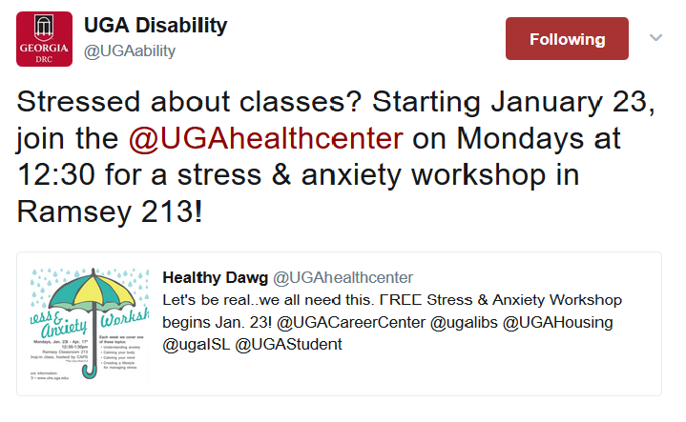
When you are writing a tweet for your department, however, you can add alternative text prior to posting. Below is an example of alternative text for tweets.
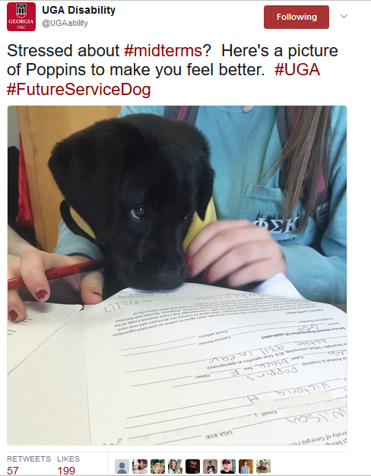

Visible Text: @UGAability: Stressed about #midterms? Here’s a picture of Poppins to make you feel better. #UGA #FutureServiceDog

Hidden Alternative Text: Black lab puppy wearing a guide dog foundation vest peers at service animal registration paperwork

Conclusion
We hope this information will assist you in creating accessible tweets! In addition to enabling alternate text, be sure to do the following to make your tweets accessible:
- Disable automatically-playing GIF files (some fast-playing GIFS can induce seizures. This will be under the same accessibility settings where you enabled alternate text).
- Write the word [LINK] before linking to another website. This may assist someone with a screen-reader in skipping the reading of a long link if they are uninterested in it.
- Capitalize the first letter in each word of a hashtag. It makes the hashtag easier to read for someone with a visual disability or a learning disability. Additionally, some screen-readers can detect individual words in a hashtag if the first letter is capitalized. If not, it will read each individual letter, which can create an internal spelling bee in your brain!
- If you cannot find a gif with alternate text, consider saving it as a still image file or writing a description of the gif in your tweet.
  - Example One: The text of my tweet below from January 25th, accompanied with a gif, reads: “FYI: If you try to shake my hand during flu season, I may lysol you.” Two lines later, the following is written in brackets to illustrate the gif: “gif: Sheldon Cooper of Big Bang Theory sprays everything with Lysol.”
    - 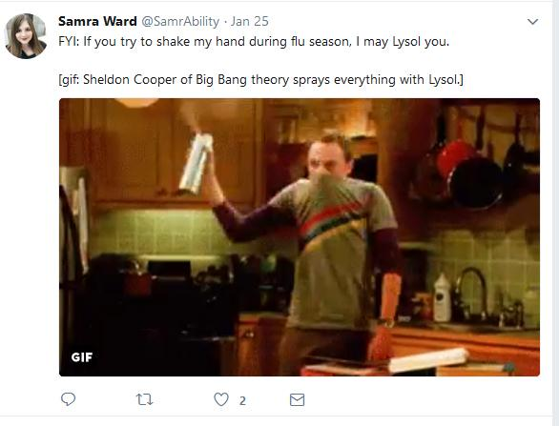
  - Example Two: The tweet below from @sofiarune on January 13 reads as follows “If you feel you may be having an anxiety attack then it might be a good time to do a breathing exercise just to slow it down a bit. [enter twice] [gif showing shapes expanding for 5 seconds with the text Breathe In followed by shapes collapsing for 5 seconds with the text Breathe Out]”
    - 