Tools for Color Contrast and
Color Blindness
Compiled by Samra Ward, M.A.

Introduction
Part of successful graphic design is making sure that it promotes the message that you intend to convey. This includes making a graphic aesthetically pleasing, easy to read, and accessible to all users. This includes users who may be colorblind. Users who are color-blind see colors differently, and as a result, may see your graphic differently or be unable to see portions of the graphic at all. Similarly, users with low-vision may have difficulty with quote-graphics and flyers that have a lower contrast. These tools, along with our colorblind-friendly palette (direct link here: http://tinyurl.com/ToolkitColorPalette), will prove useful when designing flyers or graphics for your office. You may also wish to use these before sharing flyers and graphics from other offices.

Color Contrast Tools
Using appropriate color contrast assists both low-vision and colorblind users. Color contrast also helps users detect details quickly and can be more aesthetically pleasing as a whole. While there are many tools out there to detect and correct color contrast, these two are our favorites:

Contrast Checker
Contrast Checker is a tool from ACart Communications, Inc. If you enter foreground and background colors, it will tell you what guidelines that the color scheme does or does not meet. Contrast Checker allows you to enter codes as an RGB code, a hex code, or drag your cursor to create a color. Contrast checker checks for the following guidelines: WCAG AA, WCAG AAA, WCAG AA at 18-pt font size, WCAG AAA at 18-point font size, general color contrast, and Color Contrast/Difference score. Direct link: http://contrastchecker.com/.

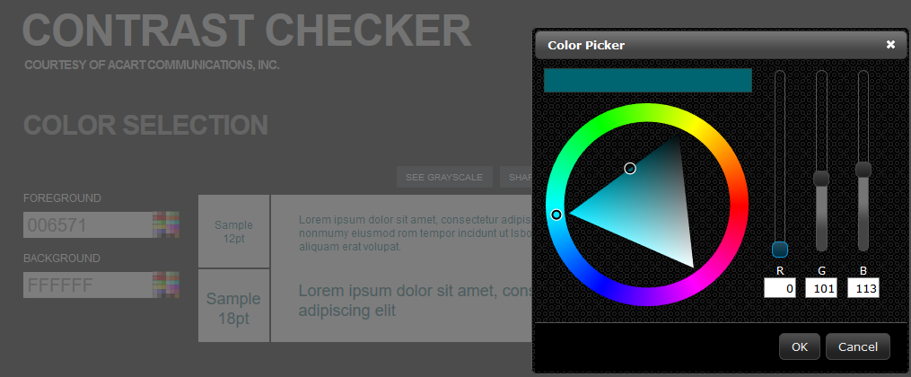
This first image is a screenshot of the color picker tool. The color picker has selected a color with a red value of 0, a green value of 101, and a blue value of 113 (hex code 006571). The background for this contrast check will be white (hex code: ffffff).

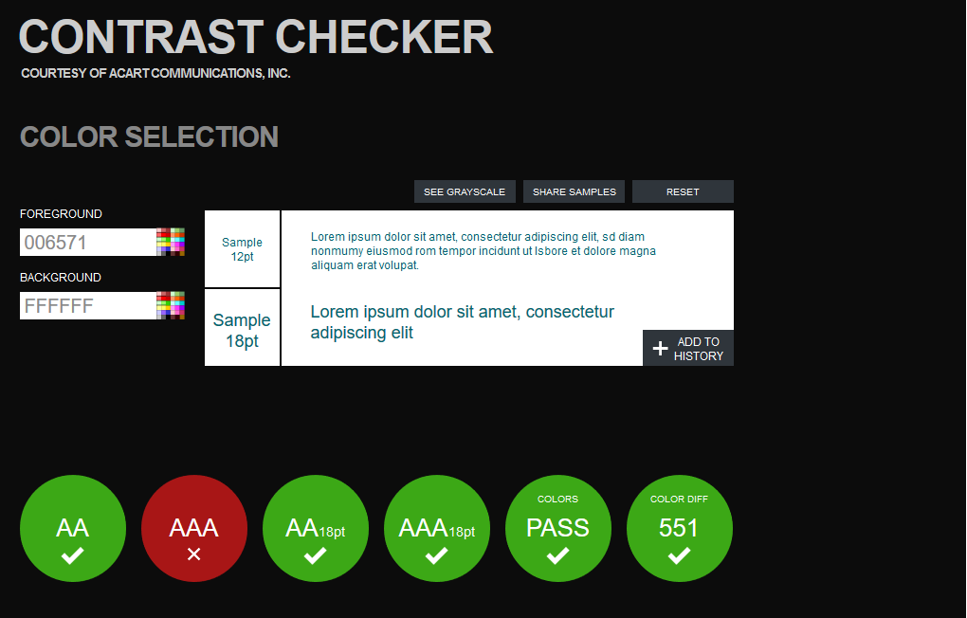
The second image is a screenshot of the contrast checker results and generates a preview of the two colors used together. The preview can also be switched from color to grayscale, to show what it may look like for colorblind users. The color scheme from screenshot one meets the following criteria: WCAG AA, WCAG AA at 18-point font, WCAG AAA at 18-point font, Color Contrast, and a Color Difference score of 551. For this tool, you must have at least a color difference of 500 to “pass.” This color scheme did not meet WCAG AAA requirements. For social media, managers generally try to meet a minimum of WCAG AA standards and WCAG AAA if possible.

Color Contrast Pal
Our second recommended tool has a simple interface that allows you to slide your mouse to a color or to enter a 6-digit hex code color. The tool will then provide you with the contrast ratio and explain whether or not it meets the color contrast requirement of 4.6 or greater. If the color contrast score is lower than four, then you will be given a link that says “auto-adjust foreground to WCAG AA.” Clicking this link will auto-correct your color to the minimum requirement. Direct link to color contrast pal: https://toolness.github.io/color-contrast-pal/.

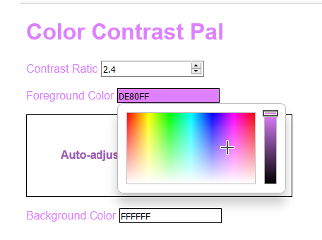
This screenshot shows the color-picker drop-down tool for Color Contrast Pal. The color is selected to a light purple (hex code DE80FF), which only has a contrast of 2.4 on a white background. Because the contrast is lower than 4.6, an “auto-adjust foreground to WCAG AA” link has been generated beneath. By clicking this link, the color will adjust to a slightly darker purple (shown in the screenshot below) with a hex code of 9e5bb5 and a contrast ratio of 4.6.
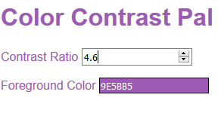
Again, these are not the only two tools for checking color contrast. There are other tools that are more technical (for example, Jonathan Snook’s Colour Contrast Checker) or can be added as an extension into your Google Chrome or Mozilla Firefox internet browser. If the above tools do not work for your needs, these may be additional places to search.

Colorblindness Tools
Having color-blindness means that a person does not see color the same way as everyone else. As a result, certain shades of color (for example: red-green and yellow-blue) may appear inverse, grayscale, or identical shades to someone with colorblindness. As a result, it is important to consider color schemes when making flyers and graphics. By using the 15-color palette in our toolkit, you will be able to have designs look remarkably the same among different types of color-blindness. Direct link to palette: http://tinyurl.com/ToolkitColorPalette. Sometimes, however, you may either have a third-party designing your graphics or even just change up your designs beyond the 15-color scheme. By using the tools below, you can see what your graphics look like to someone with various forms of colorblindness. Additionally, some of the tools can help to correct the contrast for colorblind users. While this is not a comprehensive list of tools, these are among our favorites:

Color Oracle
Color Oracle is a free, open-source software available for download on Windows, Mac, and Linux computers. This will prove useful for those times when you are designing graphics without access to internet. Color Oracle simulates three kinds of color-blindness (deuteranopia, protanopia, and tritanopia), which are three of the most extreme forms of color-blindness. Designing for the most extreme forms ensures that you will meet requirements for more minor forms of color-blindness. Color Oracle comes with a manual, designing tips for maps, and links to other programs and research. Direct link: http://colororacle.org/.

Vischeck
VisCheck (direct link: www.vischeck.com) allows users to upload graphics and PowerPoint slides that they have already created to see how they will look to users who have deuteranopia, protanopia, and tritanopia color-blindness. Additionally, VisCheck allows users to run a web-page with color-blind simulation, which means that you can check your already-existent content on social media all at once. Below is a screenshot of how VisCheck works.

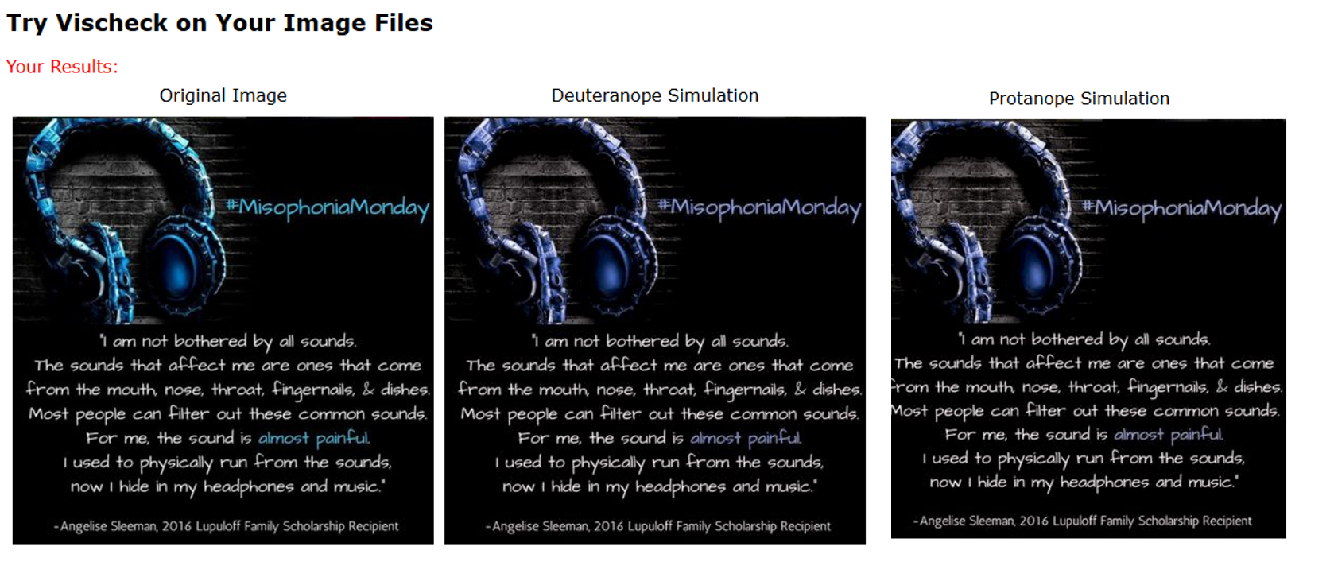
The above screenshot shows 3 graphics. The first is a quote graphic of original colors. The second shows what the design looks like to someone with deuteranope color-blindness, and the third shows what the design looks like to someone with protanope simulation. All three designs are remarkably similar, because Samra used the color-blind friendly color palette found within the toolkit.

Coblis
Coblis, similar to VisCheck, is a Color Blindness Simulator that allows users to upload images and compare them to a normal color lens. Colblis has more visual options such as dichromatism and monochromatism. Because Coblis does not upload images to a server, it is also more user-friendly for larger image files. Direct link: http://www.color-blindness.com/coblis-color-blindness-simulator/.

Daltonize
Daltonize is a sub-tool of VisCheck (direct link: http://www.vischeck.com/daltonize/ ). Rather than focusing on the colors themselves, Daltonize seeks to change the contrast of red/green or blue/yellow so that users can tell the difference in objects and their surroundings. As of 5/29, the tool is temporarily down; however, an email address is listed on their website for having an individual within their office run images “by hand.”

There are also chrome and firefox extensions for daltonizing images.

