Alternate Text on Instagram

Introduction
Because Instagram is an application that is based on photos and visual graphics, it can often be difficult to determine where to place alternate text for these pictures. It can also be difficult to convince people unfamiliar with disabilities that alternate text is relevant on an image-based application. Below, we will give research about instagram and examples of where to place alternative text.

Facts and Research
Alternate text can help connect some 285 million individuals who are blind and low vision with photographic media. On average, 2 billion photos are uploaded daily to various social media platforms, and the exclusion of alternate text from these photos perpetuates a culture of ableism.

Examples of Alternative Text on Instagram
Below are a sampling of Instagram photos that are utilizing alternate text to create a more inclusive experience for all users. Note how and where the text is included in each example.

Example One
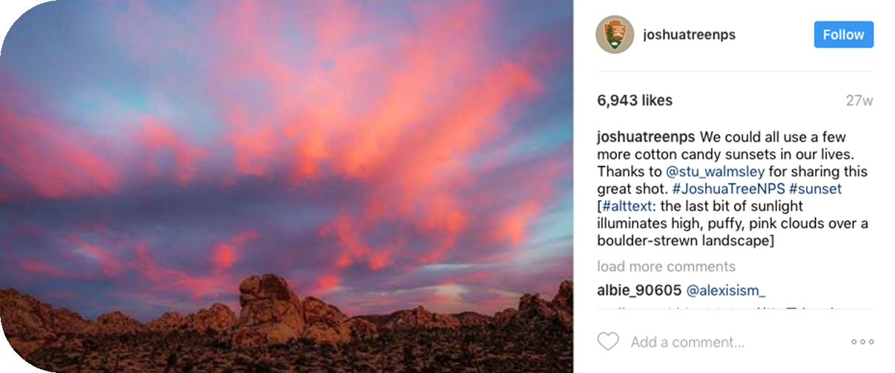

This is a great example of a lusher alternate text description. Joshua Tree does a great job of capitalizing each word in some of their hashtags, which is an excellent practice. This makes it easier for screen readers to discern the individual words and creates more cohesion when accessing the text. They also included a hashtag for #alttext to assist with individuals who may be searching for this specifically. The alt text description is included at the end of the comment, separated by brackets. This is a popular practice, and most examples I’ve found present it this way. An advantage of this style is that all the information is included in one block of text so it can be easier to navigate.

Direct link to the accessible Instagram post: https://www.instagram.com/p/BLglPyQh2s8/?taken-by=joshuatreenps

Example Two
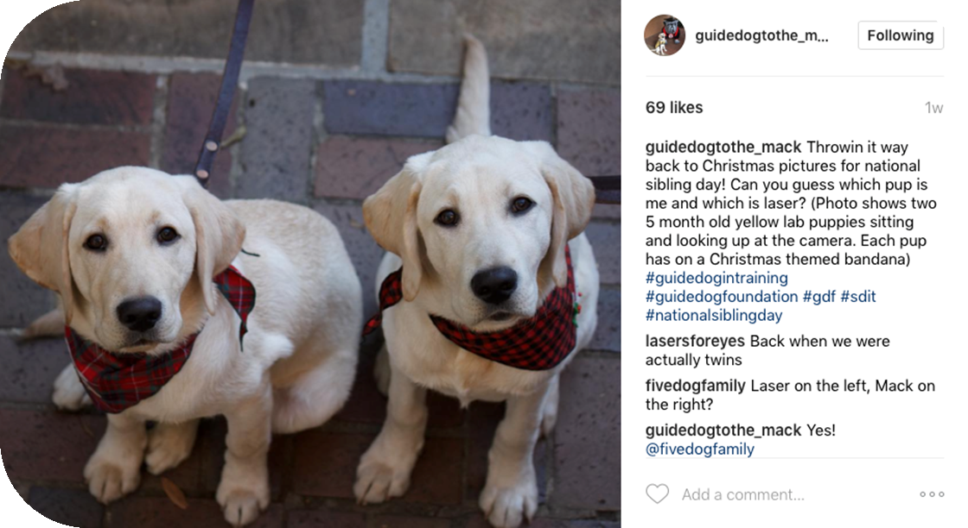
This is another great example from a student at the University of Georgia. She provides an excellent and straightforward description of the photo. The only suggestion on how to make this more excellent would be to capitalize each new word in the hashtags!

Direct link to the accessible Instagram post: https://www.instagram.com/p/BStu7gqFJq4/?taken-by=guidedogtothe_mack

Example Three
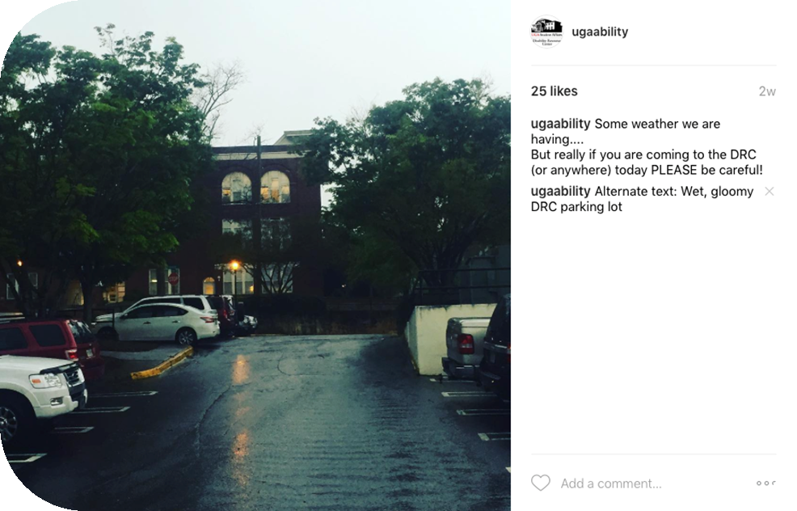

This is an example from the UGA Disability Resource Center’s instagram. We chose to put the alt text in a second comment because we feel that it is a little more inclusive. Many of our students have Learning Disabilities in reading, or Auditory Processing Disorders, and providing too much text at once may feel a little overwhelming. By breaking the information down into separate comments, we hope that we are creating a better experience for all of our students. This is simply a matter of preference, so please do what feels best for you and your students.
Direct link to the accessible Instagram post: https://www.instagram.com/p/BSgrMdygxY0/?taken-by=ugaability

Example Four

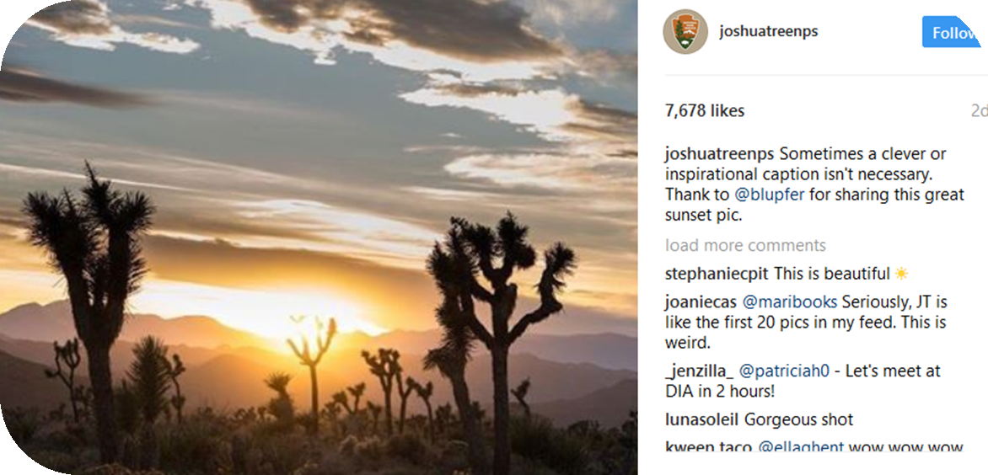

Here is another example from Joshua Tree National Parks. Sometimes no alt text is needed because the comment provides a pretty clear picture. It is important to not get so entrenched into the idea of providing alt text that you are not taking into account the scope of someone’s abilities and providing duplicate information.

Example of duplication:
Comment- Catching the sunset tonight at the beach. WOW it is beautiful #AllTheColors #Sunset

Alternate Text: Beautiful sunset at the beach

Example Five
In some cases, hidden alternate text may be useful. Hidden alternate text is best employed when using Instagram for marketing purposes (e.g., flyers, campaigns) or when the caption may provide most of the meaning for the picture, as in example four.

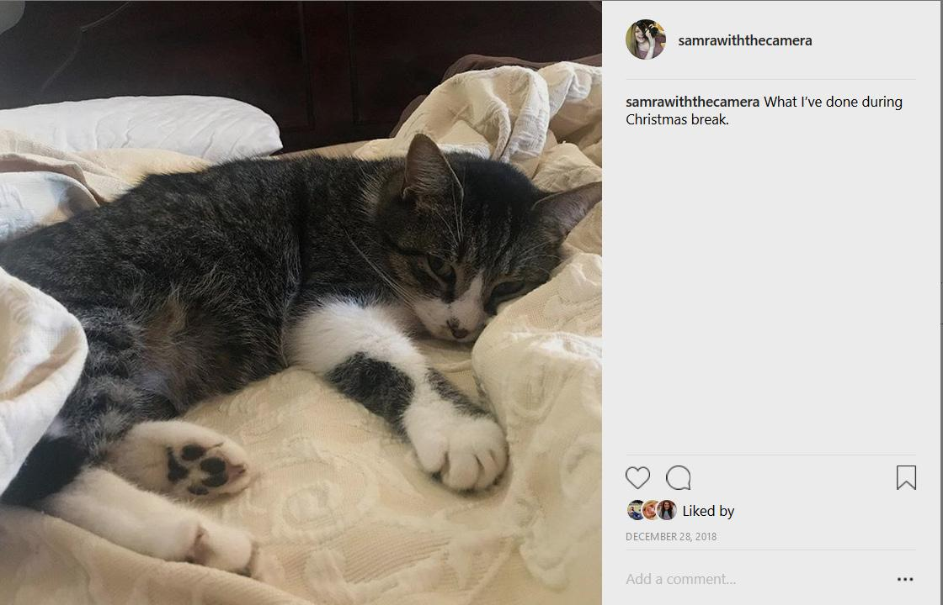

This instagram post gives zero context in the caption about what is in the picture, as I was trying to make a joke about how I am very much like this sleepy, adorable cat resting lazily on his pillow. Instead, I opted for hidden alternate text so that my followers who use a screen-reader would still get the joke and simply captioned it, “What I’ve done during Christmas break.”

The screenshot on the following page demonstrates the hidden alternate text that screen-reader users would encounter.

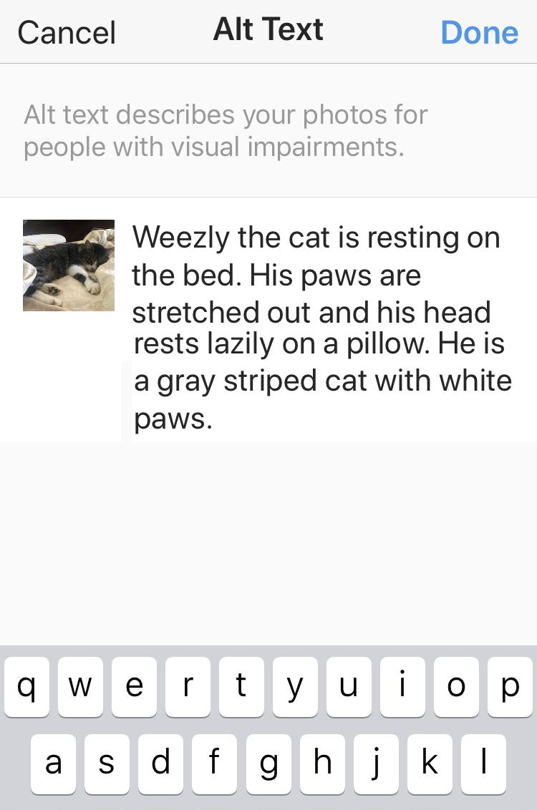

The screenshot displays the following alt text from the previous instagram post: "Weezly the cat is resting on the bed. His paws are stretched out and his head rests lazily on a pillow. He is a gray striped cat with white paws."

By having hidden alt text, I am able to make the joke about being like my family cat to both users with screen readers and users without.

In my personal opinion, using visible image descriptions when able does help create a culture of accessibility. Hidden alternate text, however, also allows a benefit of screen-reader users being able to skip images that are not of interest.

Interested in enabling alternate text for instagram? Check out this useful tutorial directly from instagram! Link: https://help.instagram.com/503708446705527 .

Screenshots of these steps may be found at this helpful instagram link: https://instagram-press.com/blog/2018/11/28/creating-a-more-accessible-instagram/ .

